
Online Benefits Enrollment Portal
We are excited to offer employees the opportunity to make benefit elections online through our benefit enrollment portal, Employee Navigator! This is a more personal way to understand the full range of benefits offered at Centenary College of Louisiana. All benefit eligible employees are required to register as a user in Employee Navigator to enroll and confirm benefit elections and verify dependent demographics.

How to Enroll in Benefits Enrolling is easy! If you are a benefits eligible employee you can complete enrollment via our enrollment system, Employee Navigator. If this is your first opportunity to use Employee Navigator, follow the steps below to register and then login to complete your enrollment.

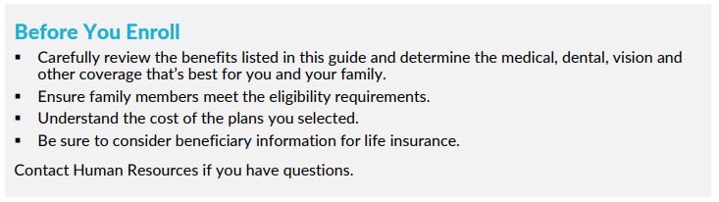

Employer Navigator Enrollment Instructions
- Go to https://marsh.employeenavigator.com
- Choose “Register as a new user” and complete the “Create Your Account” section
  - Enter the company identifier: 100-CCLA
  - Enter PIN: last four digits of your Social Security Number
  - Password: must be at least six characters and contain a symbol (#, ?, @, etc,) and a number
- Returning User? Enter your username and password or select “Rest a forgotten password”
- Click “Start” to begin your enrollment
  - you’ll need to complete some personal & dependent information before moving to your benefit elections.
TIP - To enroll a dependent in coverage you will need their date of birth and Social Security number

- Benefit Elections
  - To enroll dependents in a benefit, click the checkbox next to the dependent’s name under Who am I enrolling? Below your dependents you can view your available plans and the cost per pay. To elect a benefit, click Select Plan underneath the plan cost.
  - Click Save & Continue at the bottom of each screen to save your elections.
  - If you do not want a benefit, click Don’t want this benefit? at the bottom of the screen and select a reason from the drop-down menu.
  - Click the “Click to Sign” button to finalize your elections.

- Forms
If you have elected benefits that require a beneficiary designation or completion of an Evidence of Insurability form, you will be prompted to add in those details.

- Review & Confirm Elections
Review the benefits you selected on the enrollment summary page to make sure they are correct then click Sign & Agree to complete your enrollment. You can either print a summary of your elections for your records or login at any point during the year to view your summary online.

TIP - If you miss a step you’ll see Enrollment Not Complete in the progress bar with the incomplete steps highlighted. Click on any incomplete steps to complete them.

Need assistance? Feel free to reach out to the Benefit Support Specialist Team at 1-844-208-5744 PIN 2143 or via email centenarybenefits@marshmma.com

You can login to review your benefits 24/7

Use the QR code below to access the 2026 Benefits Guide



